|  |  |  |
| --- | --- | --- |
|  | **GUJARAT TECHNOLOGICAL UNIVERSITY**  Chandkheda, Ahmedabad  Affiliated |  |

SardarVallabhbhai Patel Institute Of Technology

Vasad-041

A

Project Report

On

**Internet of Things**

Under the course of

**DESIGN ENGINEERING – 1A (2130005)**

B. E. II, Semester – III

**(Information Technology)**

***Submitted by:***

GroupID : 5295

|  |  |  |
| --- | --- | --- |
| **Sr.** | **Name of student** | **Enrolment No.** |
|  |  |  |
| 1 | Kaushiki Kansara | 160410116048 |
| 2 | Karansinh Matroja | 160410116055 |
| 3 | Jeet Meghpara | 160410116056 |
|  |  |  |
|  |  |  |

|  |  |
| --- | --- |
| **Prof.**  **Amit Kariyani**  **(Faculty Guide)** | **Prof.**  **N.V. Shah**  **(Head Of Department)** |

**Academic year**

**(2017-2018)**

|  |  |  |
| --- | --- | --- |
|  | **GUJARAT TECHNOLOGICAL UNIVERSITY**  Chandkheda, Ahmedabad  Affiliated |  |

**CERTIFICATE**

This is to certify that the students namely, **Kaushiki Kansara(160410116048), Karansinh Matroja(160410116055), Jeet Meghpara(160410116044)** of ***B. E. ( Information Technology) Semester III*** have successfully completed the course work and related tasks for the course of **Design Engineering 1A (2130005)** during the academic term ending in the month of October 2017.

Date: 10-10-2017

Place: SVIT VASAD

**Mrs. . Prof.N.V.Shah** (Internal Guide)Head of the Department

**(External Examiner)**

Contents

1. Introduction 5

1.1 About Team Member 5

1.2 About Guide Faculty 5

2. A.E.I.O.U Canvas 6

2.1 A – Activity 6

2.2 E – Environment 6

2.3 I – Interaction 6

2.4 O – Objects 6

2.5 U – Users 6

3. Mind mapping 8

4. Empathy Mapping 9

5. Ideation Canvas 10

5.1 People 10

5.2 Activities 10

5.3 Situation/Context/Location 10

5.4 Props/Possible Solution 10

6. Product Development Canvas 12

6.1 Purpose: 12

6.2 People: 12

6.3 Product Experience: 12

6.4 Product function: 12

6.5 Product features: 12

6.6 Components: 12

6.7 Mobiles/tables 12

6.8 Customer Revalidation: 13

6.9 Reject, Redesign, Points: 13

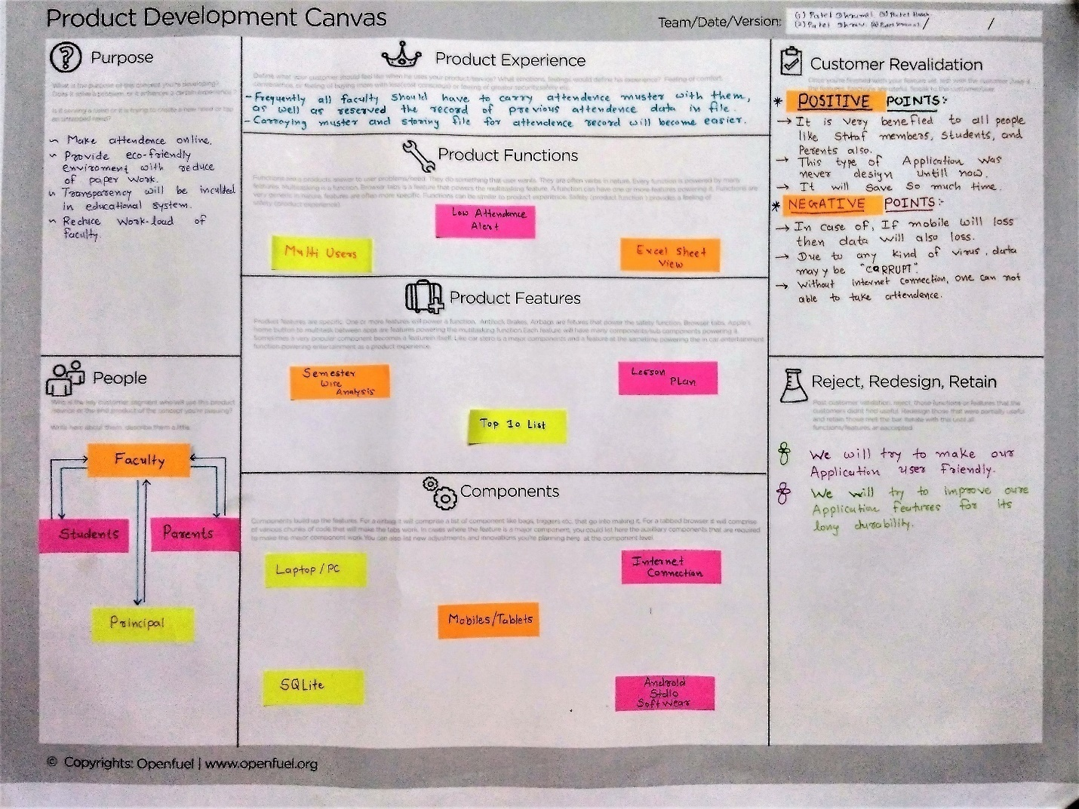 13

# Introduction

We observed that for farmers there are no proper ways to get their crop production sell easily in the market. There is no proper method to estimate the crop production and store the data. So we are making an app/software that can help farmers and retailers estimate and store the crop production.

## About Team Member

 In our group, we are 4 members named Patel Jeet (160410116043), Gupta Akshay (160410116039), Delavadiya Satish (160410116026), and Kachhiya Harshil (160410116044).

## 1.2 About Guide Faculty

In over group, there is one internal faculty guide named Mr. Who is very good and experience teacher in Design Engineering subject. he always giving us advise what to do and what don’t.

# A.E.I.O.U Canvas

There are five points that are comes in AEIOU canvas that we discuss hear.

## A – Activity

* tilling > Spraying of pesticides
* Live-stock production > Harvesting
* Plant breeding >Ploughing
* Storage and estimation

## E – Environment

* Farm-near to village > Availability of water
* Farm-near to city > Land Fertility
* Unbalance temperature > Changing ecosystems

## I – Interaction

* Farmer
* Merchant
* Worker
* Land workers
* Government Agriculturists

## O – Objects

* Seeds > Pesticides
* Farming equipments > Laptops/PC
* Software/databases > Truckes

## U – Users

* Farmer

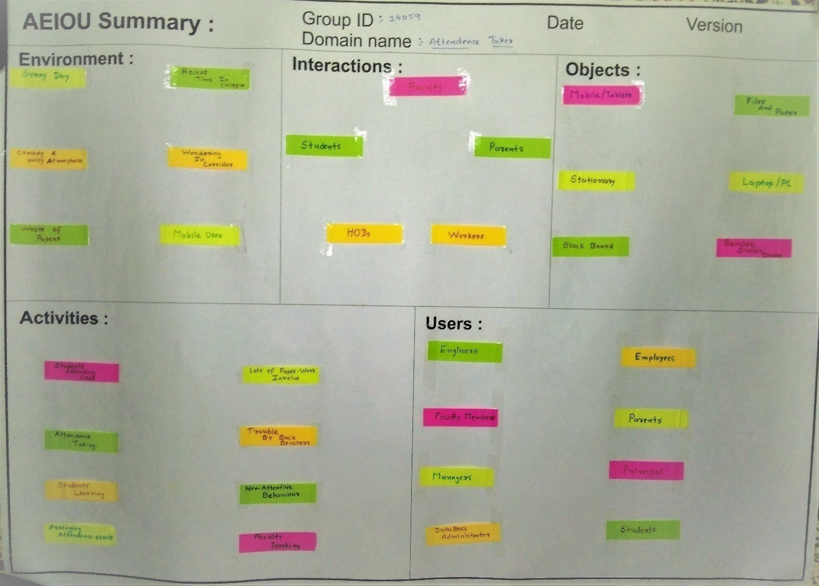Figure 1 A.E.I.O.U Canvas

# Mind mapping

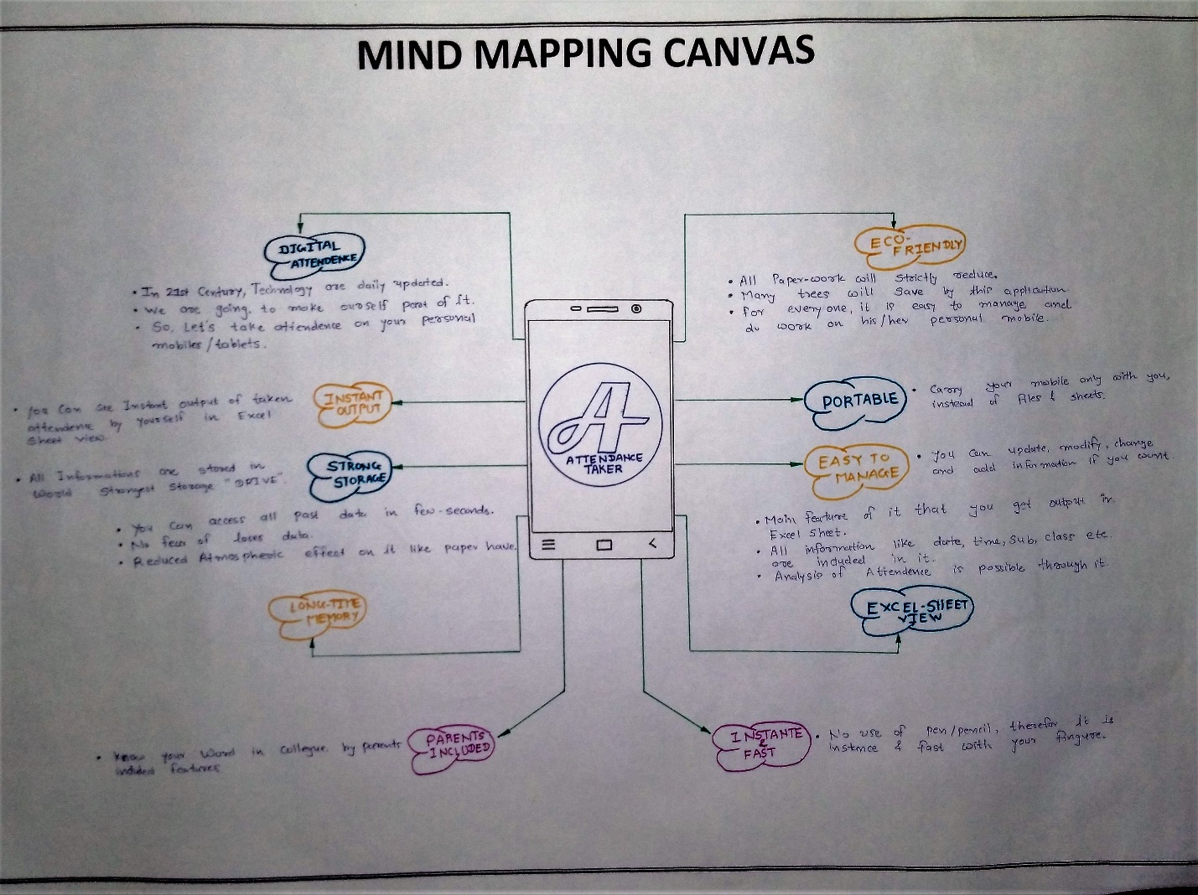

Figure 2 Mind mapping

There are mainly ten feature in mind mapping canvas. That are going to discuss below.

* Crop-cut Method > pastoral farming
* Organic Farming
* Food processing
* Farmer’s estimates
* Whole-plot harvest
* Daily recording
* Monoculture

# Empathy Mapping

Here we going to explain users, stack holders and activity. And hear story boarding which have 2 story, one of the happy and another one is sad. So the features of empathy canvas is below.

## Users:

* Farmer

## Stockholders:

* Barn workers
* Artificial Breeding
* Multiple Agencies
* Government

## Activity:

* Tilling
* Crop rotation
* Plantation
* Harvesting
* Breeding
* irrigation
* Storage and estimation

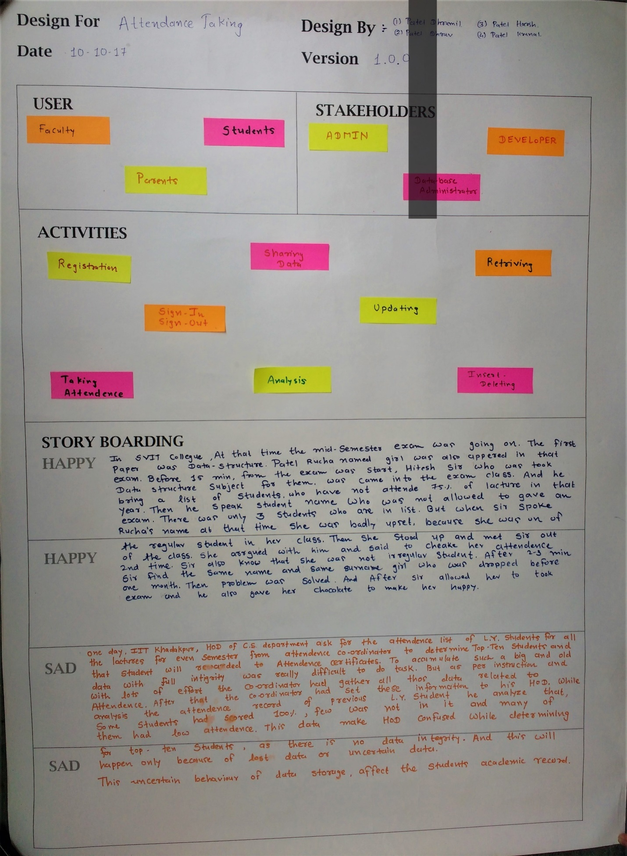

# Ideation Canvas

Ideation canvas Second task was to create” THE IDEATION CANVAS”. We described activities of people and situation or location where they are facing problems. This canvas is very helpful to reach near our goal. This canvas helped us to know what the areas which need focus are. There are mainly 4 points we are going to know below.

## People

* Farmer > Agriculturists > Barn Worker

>Land owners >Food industries

## Activities

* Livestock production
* Irrigation > Ploughing
* Harvesting > Tilling

## Situation/Context/Location

* Price inflation > loss of crops
* Labs > Poor irrigation
* Crop estimation

## Props/Possible Solution

* Crop estimation methods > Daily recording > Database
* Whole plot harvest
* Crop cut method
* Farmer’s estimates

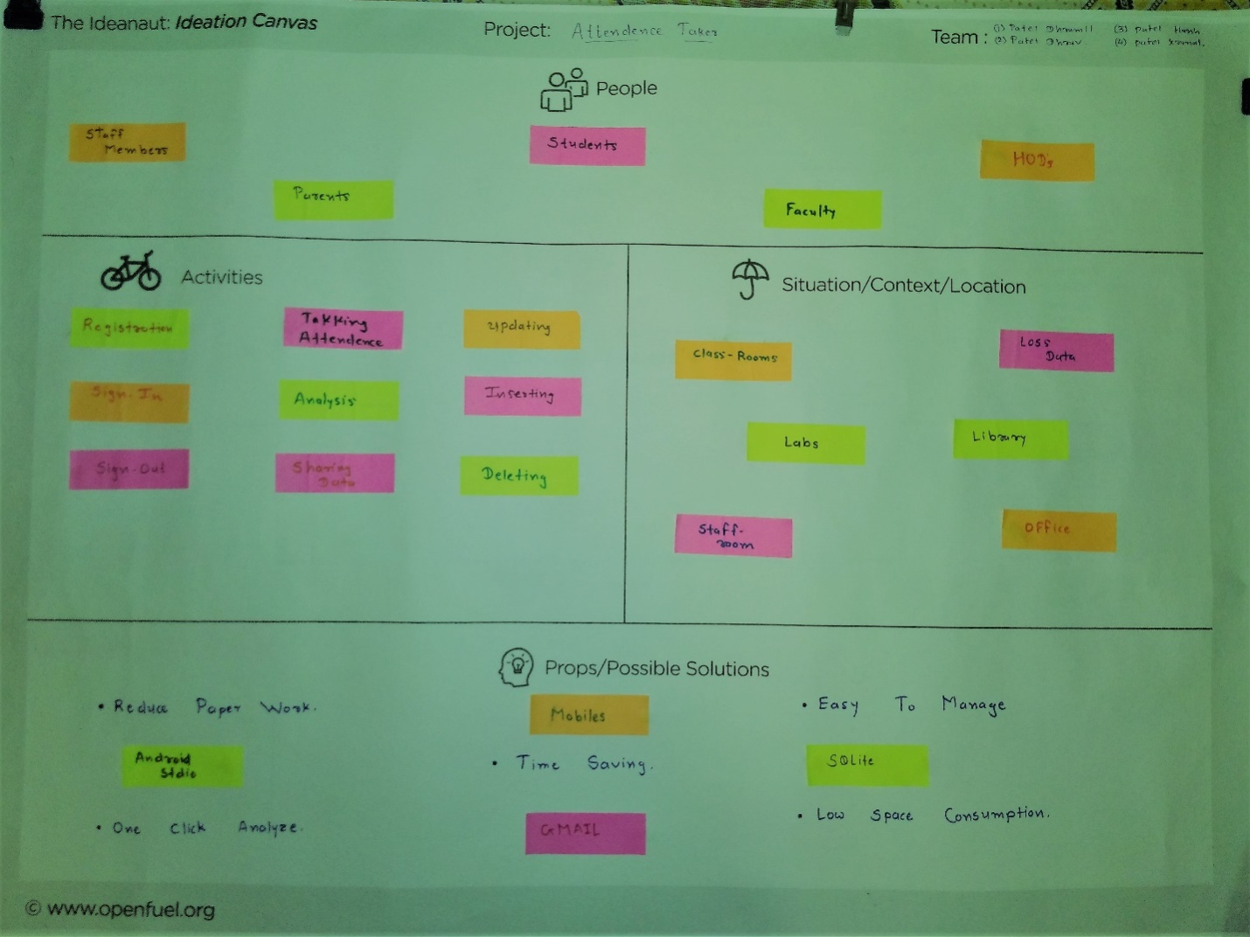

Figure 4Ideation Canvas

# Product Development Canvas

The third task was to create “PRODUCT DEVELOPMENT CANVAS”. It’s helpful to understand of purpose, product experience and product function of our project.

**All points are describe below:**

## Purpose:

* Proper database
* Provide farmer’s a platform to sell their products
* Perfect production estimates
* Crop records

## People:

* Farmer > Agriculturists >Land owners

> Farm employees

## Product function:

* Perfect estimation
* Proper payment methods
* Crop data records

## Product features:

* Consistency
* Subsidized price
* No duplicate data
* Accuracy

## Components:

* Farming equipments
* Private servers
* Computers
* Databases

## 

Figure 5 Product development Canvas